Week No 10:
Slide No 1:
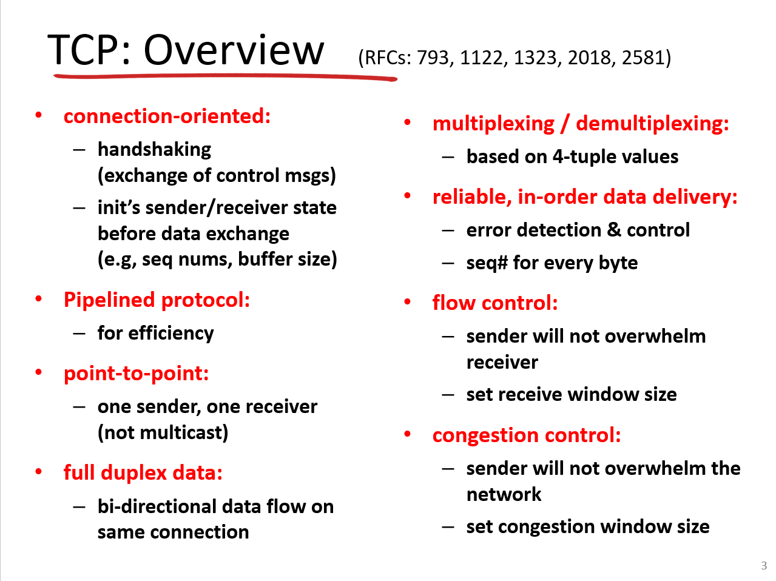

📘 TCP Overview – Simple English Explanation

1. Connection-Oriented
- TCP is like making a phone call: before talking, you say “Hello” and the other person replies.
- This is called handshaking. It sets up rules (sequence numbers, buffer sizes) before sending data.

2. Pipelined Protocol
- TCP doesn’t wait for one packet to finish before sending the next.
- It sends multiple packets in a pipeline to improve efficiency.

3. Point-to-Point
- One sender, one receiver. TCP is not multicast (you can’t send to many at once).

4. Full Duplex
- Data flows both ways at the same time (like talking on the phone).

5. Multiplexing/Demultiplexing
- TCP uses a 4-tuple (source IP, source port, destination IP, destination port) to identify connections.
- This allows multiple apps to use TCP at the same time.

6. Reliable, In-Order Delivery
- TCP ensures data arrives without errors and in the correct order.
- Every byte has a sequence number.

7. Flow Control
- TCP prevents the sender from overwhelming the receiver.
- Receiver sets a window size (how much data it can handle).

8. Congestion Control
- TCP prevents the sender from overwhelming the network.
- It uses a congestion window to adjust sending speed.

📗 Roman Urdu Explanation (Professor Style)
- Connection-Oriented: TCP aise hai jaise phone call karna. Pehle handshake hota hai (hello, hello reply). Ye handshake sender aur receiver ki state set karta hai – jaise sequence numbers aur buffer size.
- Pipelined Protocol: TCP ek ek packet ka wait nahi karta. Ek pipeline banata hai jisme multiple packets ek saath bhejte hain taake efficiency barh jaye.
- Point-to-Point: TCP sirf ek sender aur ek receiver ke darmiyan hota hai. Ye multicast nahi hai.
- Full Duplex: Data dono taraf ek hi waqt flow kar sakta hai – jaise phone pe baat karte waqt dono bol sakte hain.
- Multiplexing/Demultiplexing: TCP 4-tuple use karta hai (source IP, source port, destination IP, destination port). Is se ek hi machine pe multiple applications TCP use kar sakti hain.
- Reliable, In-Order Delivery: TCP guarantee karta hai ke data bina error ke aur sahi order mein pohonche. Har byte ka sequence number hota hai.
- Flow Control: Sender ko control kiya jata hai taake wo receiver ko overwhelm na kare. Receiver apna window size set karta hai.
- Congestion Control: TCP network ko protect karta hai. Agar network congest ho jaye to TCP apna congestion window adjust karta hai aur bhejne ki speed slow kar deta hai.

📝 Practice Questions

Multiple Choice (MCQs)
- TCP is: a) Connectionless b) Connection-Oriented c) Multicast protocol d) None of the above
- Which mechanism prevents sender from overwhelming the receiver? a) Congestion Control b) Flow Control c) Error Detection d) Multiplexing
- TCP identifies connections using: a) MAC address b) 4-tuple (IP + Port) c) Only IP address d) Sequence number
- Which feature ensures data arrives in correct order? a) Flow Control b) Reliable Delivery c) Multiplexing d) Handshaking

True/False
- TCP supports multicast. → False
- TCP is full duplex. → True
- Every byte in TCP has a sequence number. → True
- Flow control prevents sender from overwhelming the network. → False (that’s congestion control)

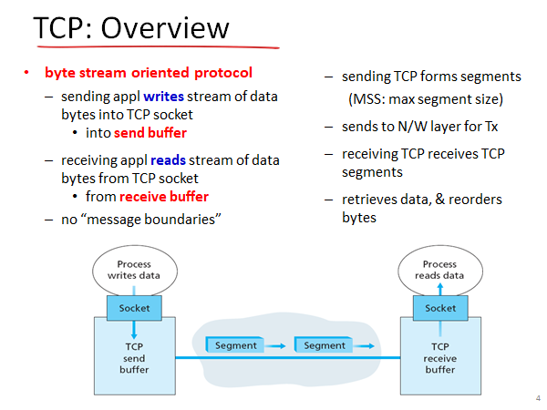
TCP Overview – Simple English Explanation

1. TCP is Byte Stream-Oriented
- TCP doesn’t send data as separate messages.
- Instead, it treats data as a continuous stream of bytes.
- The sending application writes bytes into the TCP socket, which go into the send buffer.
- The receiving application reads bytes from its TCP socket, which come from the receive buffer.
- There are no message boundaries — TCP doesn’t care where one message ends and another begins.
👉 Example: If you send “HelloWorld” in one go, TCP might break it into two segments: “Hello” and “World”. The receiver will still get “HelloWorld” correctly, but TCP doesn’t mark where “Hello” ended — it just delivers bytes in order.

2. Segmentation
- TCP divides the byte stream into segments before sending them.
- Each segment has a Maximum Segment Size (MSS) — the largest chunk TCP can send at once.
- These segments are passed to the network layer for transmission.

3. Reassembly
- On the receiving side, TCP collects segments, reorders them if needed, and rebuilds the original byte stream.
- The receiving application just reads bytes — it doesn’t see the segments.

4. No Message Boundaries
- Unlike UDP (which sends messages), TCP doesn’t preserve message limits.
- It’s like a continuous pipe — data flows smoothly from sender to receiver.

💬 Roman Urdu Explanation (Professor Style)
- TCP Byte Stream-Oriented hai: TCP data ko alag alag messages ke form mein nahi bhejta. Ye ek continuous stream of bytes ke taur pe data bhejta hai. Sender application apne TCP socket mein data likhta hai, jo send buffer mein store hota hai. Receiver application apne TCP socket se data read karta hai, jo receive buffer se aata hai. TCP mein message boundaries nahi hoti — matlab TCP ko fark nahi padta ke ek message kahan khatam hua aur doosra kahan shuru.
👉 Example: Agar aap “HelloWorld” bhejte ho, TCP usay do segments mein tod sakta hai: “Hello” aur “World”. Receiver ko dono milenge aur wo “HelloWorld” reconstruct kar lega, lekin TCP ne message ke end ka koi mark nahi lagaya.
- Segmentation: TCP data ko chhoti chhoti segments mein divide karta hai. Har segment ka ek Maximum Segment Size (MSS) hota hai. Ye segments network layer ko bheje jaate hain taake transmission ho sake.
- Reassembly: Receiver TCP in segments ko receive karta hai, agar order galat ho to reorder karta hai, aur phir original byte stream bana deta hai. Receiver application ko bas bytes milti hain — usay segments ka pata nahi hota.
- No Message Boundaries: UDP ke opposite, TCP message boundaries maintain nahi karta. Ye ek continuous pipe jaisa hai jahan data smoothly flow karta hai.

🧩 Practice Section

Multiple Choice Questions (MCQs)
- TCP is a ______ protocol. a) Message-oriented b) Byte stream-oriented c) Packet-oriented d) Frame-oriented
- The maximum amount of data TCP can send in one segment is called: a) MTU b) MSS c) MSL d) RTT
- TCP sends data to the network layer in the form of: a) Frames b) Segments c) Packets d) Streams
- TCP provides ______ boundaries. a) Message b) Byte c) Segment d) None

True/False
- TCP preserves message boundaries. → False
- TCP is a byte stream-oriented protocol. → True
- TCP uses segments for data transmission. → True
- TCP receiver reads data directly from the network layer. → False (It reads from the TCP socket and receive buffer)

Summary
Concept | Explanation
Byte Stream | Continuous flow of bytes, not messages
Send Buffer | Stores outgoing data written by sender
Receive Buffer | Stores incoming data read by receiver
MSS | Maximum size of a TCP segment
No Message Boundaries | TCP doesn’t separate messages
Reassembly | Receiver reorders and rebuilds byte stream
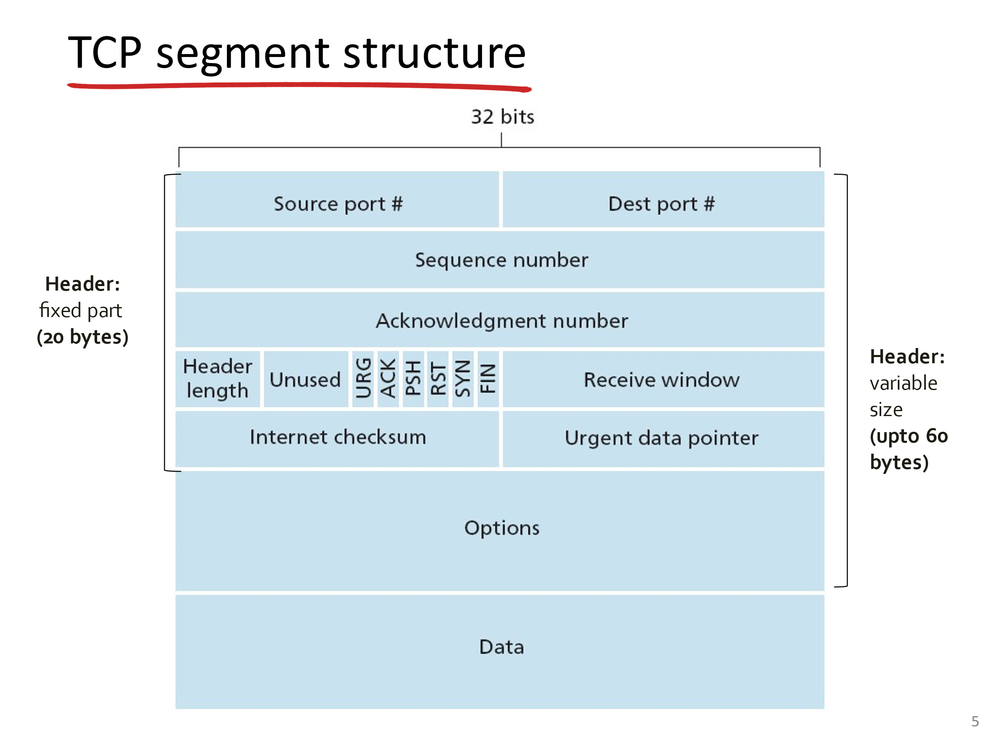

TCP Segment Structure – Simple English Explanation
A TCP segment is the basic unit of data transmission in TCP. It has a header (control information) and data (payload).

1. Source Port & Destination Port (16 bits each)
- Identify which application is sending and which application is receiving.
- Example: Web server uses port 80, client uses a random port.

2. Sequence Number (32 bits)
- Every byte of data has a number.
- This field tells the receiver where this segment fits in the overall stream.

3. Acknowledgment Number (32 bits)
- Used by the receiver to confirm which bytes it has successfully received.
- Example: If ACK = 101, it means “I’ve received all bytes up to 100.”

4. Header Length
- Tells how long the TCP header is (minimum 20 bytes, maximum 60 bytes).

5. Flags (Control Bits)
- URG: Urgent data
- ACK: Acknowledgment valid
- PSH: Push data immediately to application
- RST: Reset connection
- SYN: Synchronize sequence numbers (used in connection setup)
- FIN: Finish connection (used in termination)

6. Receive Window (16 bits)
- Flow control mechanism.
- Tells sender how much data the receiver can accept.

7. Checksum
- Error detection. Ensures data integrity.

8. Urgent Pointer
- Points to urgent data if URG flag is set.

9. Options
- Extra features like Maximum Segment Size (MSS), window scaling, etc.

10. Data
- Actual payload (the application’s message).

📗 Roman Urdu Explanation (Professor Style)
- Source aur Destination Port: Ye batata hai ke kaunsa application data bhej raha hai aur kaunsa receive kar raha hai. Example: Web server port 80 use karta hai.
- Sequence Number: Har byte ka ek number hota hai. Ye field batati hai ke segment stream mein kahan fit hota hai.
- Acknowledgment Number: Receiver sender ko batata hai ke kitne bytes successfully receive ho gaye. Agar ACK = 101 hai, matlab 100 tak ke bytes mil gaye.
- Header Length: TCP header ki length batata hai. Minimum 20 bytes, maximum 60 bytes.
- Flags (Control Bits):
- URG → urgent data
- ACK → acknowledgment valid
- PSH → push data immediately
- RST → reset connection
- SYN → connection setup
- FIN → connection terminate
- Receive Window: Flow control ke liye use hota hai. Receiver sender ko batata hai ke kitna data accept kar sakta hai.
- Checksum: Error detection ke liye hota hai. Data sahi hai ya corrupt, ye check karta hai.
- Urgent Pointer: Agar URG flag set ho to urgent data ka pointer hota hai.
- Options: Extra features jaise MSS aur window scaling.
- Data: Ye actual payload hota hai jo application bhejti hai.

📝 Practice Questions

Multiple Choice (MCQs)
- Which field in TCP ensures data arrives in correct order? a) Port number b) Sequence number c) Flags d) Checksum
- Which flag is used to start a TCP connection? a) ACK b) SYN c) FIN d) RST
- The minimum size of a TCP header is: a) 10 bytes b) 20 bytes c) 40 bytes d) 60 bytes
- Which field is used for error detection? a) Sequence number b) Checksum c) Window size d) Urgent pointer

True/False
- TCP header length can vary between 20 and 60 bytes. → True
- The FIN flag is used to establish a connection. → False (It’s used to terminate)
- The checksum ensures data integrity. → True
- Sequence numbers are only used during connection setup. → False (They’re used throughout transmission)

🎯 Quick Recap
Field | Purpose
Source/Dest Port | Identify applications
Sequence Number | Order of bytes
ACK Number | Confirm received bytes
Flags | Control connection (SYN, FIN, etc.)
Window Size | Flow control
Checksum | Error detection
Options | Extra features
Data | Payload

Above slides read from lectures
Slides No 14:
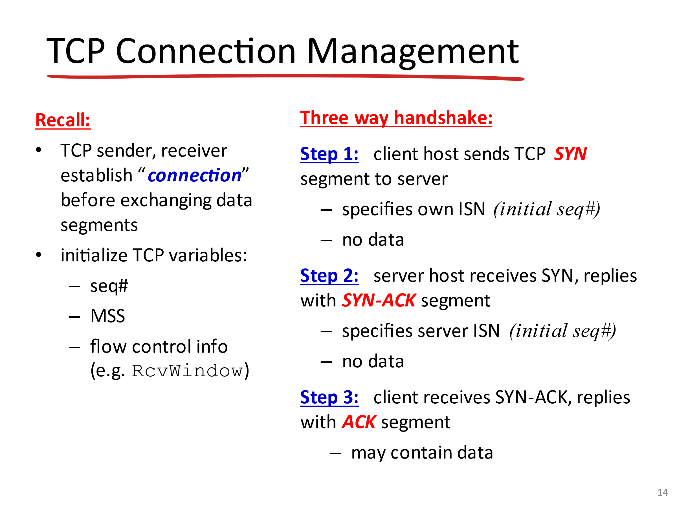

📘 TCP Connection Management – Simple English Explanation

1. Connection Setup
- TCP is connection-oriented.
- Before sending data, the sender and receiver must establish a connection.
- They initialize important variables:
  - Sequence numbers (seq#) → to keep track of bytes.
  - MSS (Maximum Segment Size) → largest chunk of data per segment.
  - Flow control info (RcvWindow) → how much data receiver can handle.

2. Three-Way Handshake
This is the process of establishing a TCP connection:
- Step 1: SYN
  - Client sends a SYN segment to the server.
  - It includes the client’s Initial Sequence Number (ISN).
  - No data is sent yet.
- Step 2: SYN-ACK
  - Server replies with a SYN-ACK segment.
  - It includes the server’s own ISN.
  - Still no data.
- Step 3: ACK
  - Client responds with an ACK segment.
  - This may include data.
  - Now the connection is established, and both sides can start exchanging data.
👉 Analogy: It’s like shaking hands —
- Client extends hand (SYN).
- Server accepts and extends back (SYN-ACK).
- Client confirms handshake (ACK).

📗 Roman Urdu Explanation (Professor Style)
- Connection Setup: TCP ek connection-oriented protocol hai. Matlab data bhejne se pehle sender aur receiver ek connection establish karte hain. Is waqt kuch variables set hote hain:
- Sequence number (seq#) → har byte ka track rakhne ke liye.
- MSS (Maximum Segment Size) → ek segment mein maximum data size.
- Flow control info (RcvWindow) → receiver kitna data handle kar sakta hai.
- Three-Way Handshake: Ye process hai jisme TCP connection establish hota hai:
- Step 1: SYN Client server ko SYN segment bhejta hai. Ismein client ka Initial Sequence Number (ISN) hota hai. Data nahi bheja jata.
- Step 2: SYN-ACK Server SYN receive karta hai aur SYN-ACK bhejta hai. Ismein server ka ISN hota hai. Data abhi bhi nahi bheja jata.
- Step 3: ACK Client SYN-ACK receive karta hai aur ACK bhejta hai. Ismein data bhi ho sakta hai. Ab connection establish ho gaya hai aur dono taraf data exchange ho sakta hai.
👉 Example: Ye bilkul handshake jaisa hai.
- Client haath badhata hai (SYN).
- Server haath milata hai (SYN-ACK).
- Client confirm karta hai (ACK).

📝 Practice Questions

Multiple Choice (MCQs)
- TCP connection setup uses: a) Two-way handshake b) Three-way handshake c) Four-way handshake d) None
- Which flag is used in the first step of connection setup? a) ACK b) SYN c) FIN d) RST
- The variable MSS stands for: a) Maximum Segment Size b) Minimum Segment Size c) Maximum Socket Size d) Message Segment Size
- Flow control information is carried in: a) Sequence number b) Receive window c) Checksum d) Urgent pointer

True/False
- TCP requires a connection before sending data. → True
- The three-way handshake involves SYN, SYN-ACK, and ACK. → True
- Data can never be sent during the handshake. → False (ACK may contain data)
- Sequence numbers are only used during connection setup. → False (They’re used throughout transmission)

🎯 Quick Recap
Step | Action | Purpose
SYN | Client → Server | Start connection, send client ISN
SYN-ACK | Server → Client | Reply, send server ISN
ACK | Client → Server | Confirm connection, may send data

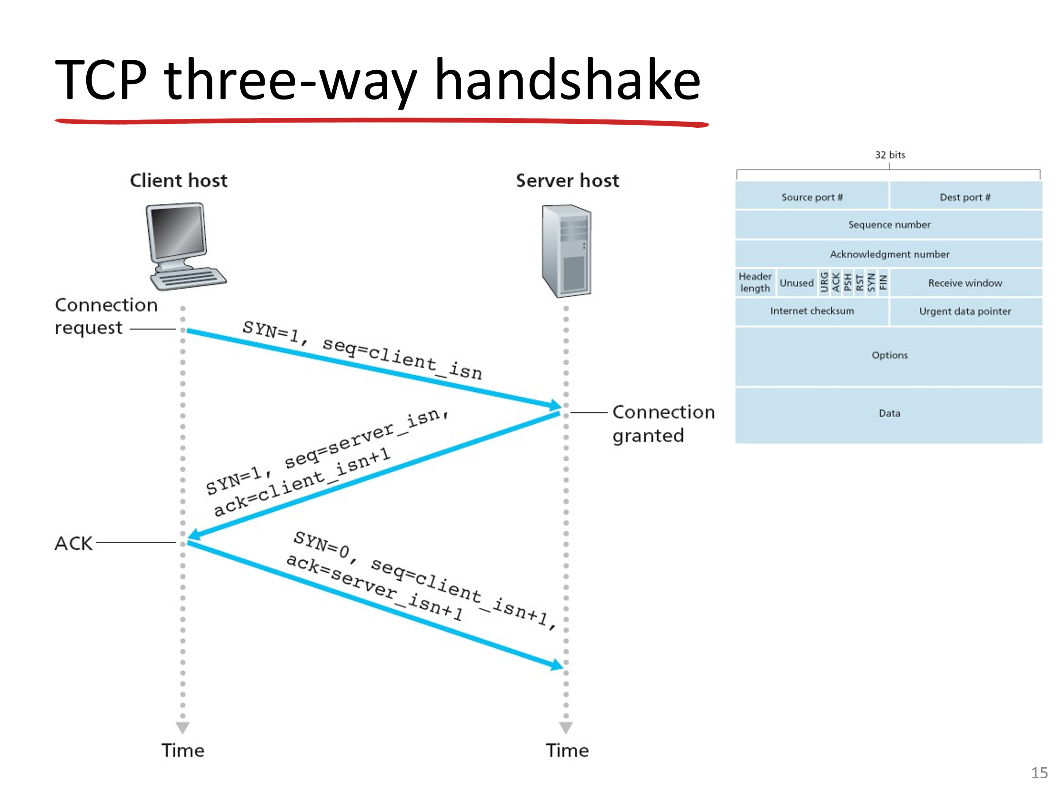TCP Three-Way Handshake – Simple English Explanation
The three-way handshake is how TCP establishes a reliable connection between client and server.

Step 1: SYN (Connection Request)
- Client sends a segment with SYN = 1.
- It includes the client’s Initial Sequence Number (ISN).
- This is like saying: “I want to start a connection, here’s my starting number.”

Step 2: SYN-ACK (Connection Granted)
- Server replies with SYN = 1, ACK = client_isn + 1.
- It includes the server’s own ISN.
- This is like saying: “Okay, I accept your request. Here’s my starting number, and I acknowledge yours.”

Step 3: ACK (Final Confirmation)
- Client sends back ACK = server_isn + 1, SYN = 0.
- This may include data.
- This is like saying: “Handshake complete, I acknowledge your number. Let’s start sending data.”
👉 Analogy:
- Client extends hand (SYN).
- Server shakes hand and acknowledges (SYN-ACK).
- Client confirms handshake (ACK). Now both sides trust each other and can communicate reliably.

📗 Roman Urdu Explanation (Professor Style)
Step 1: SYN (Connection Request) Client server ko ek segment bhejta hai jisme SYN = 1 hota hai. Ismein client ka Initial Sequence Number (ISN) hota hai. Matlab: “Main connection start karna chahta hoon, ye mera starting number hai.”
Step 2: SYN-ACK (Connection Granted) Server reply karta hai ek segment ke sath jisme SYN = 1, ACK = client_isn + 1 hota hai. Ismein server ka ISN bhi hota hai. Matlab: “Main tumhara request accept karta hoon, ye mera starting number hai, aur tumhara acknowledge kar raha hoon.”
Step 3: ACK (Final Confirmation) Client ek ACK bhejta hai jisme ACK = server_isn + 1, SYN = 0 hota hai. Ismein data bhi ho sakta hai. Matlab: “Handshake complete, tumhara number acknowledge kar raha hoon. Ab data exchange shuru karte hain.”
👉 Example: Bilkul handshake jaisa hai.
- Client haath badhata hai (SYN).
- Server haath milata hai (SYN-ACK).
- Client confirm karta hai (ACK).

📝 Practice Questions

Multiple Choice (MCQs)
- How many steps are in the TCP handshake? a) 2 b) 3 c) 4 d) 5
- In the first step, the client sends: a) SYN = 0 b) SYN = 1 with client ISN c) ACK = 1 d) FIN = 1
- In the second step, the server sends: a) SYN only b) SYN + ACK c) ACK only d) FIN
- The final ACK from the client includes: a) SYN = 1 b) SYN = 0, ACK = server_isn + 1 c) FIN = 1 d) RST = 1

True/False
- TCP uses a two-way handshake. → False
- The client’s first message includes its Initial Sequence Number. → True
- The server’s SYN-ACK acknowledges the client’s ISN. → True
- The final ACK may contain data. → True

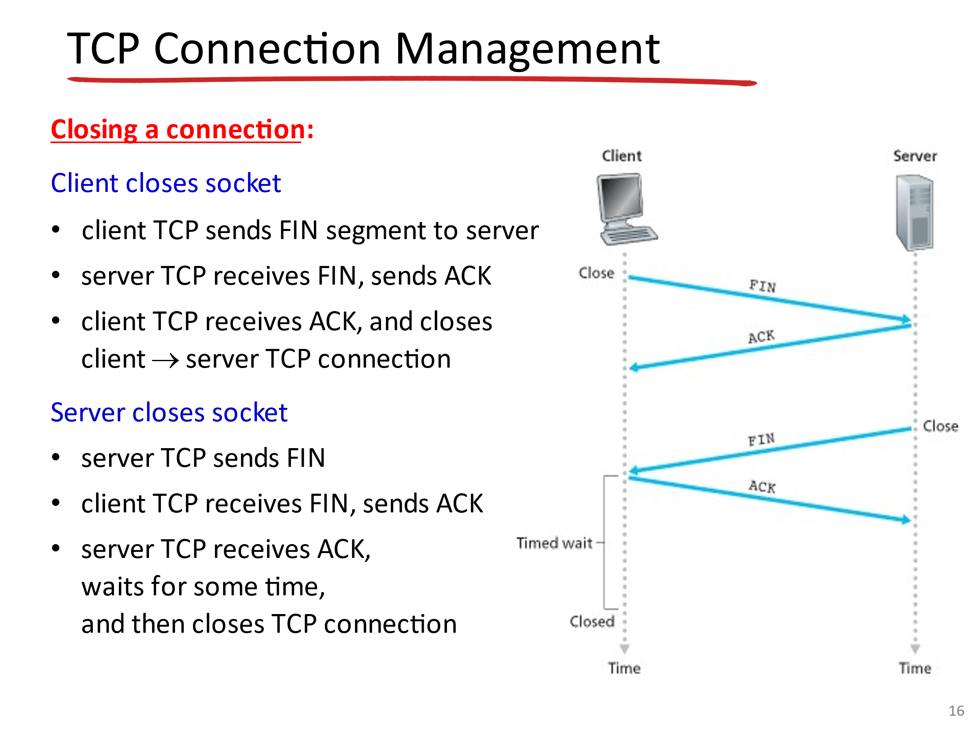📘 TCP Connection Closing – Simple English Explanation
TCP doesn’t just “cut off” a connection suddenly. It closes gracefully using a four-step handshake with the FIN and ACK flags.

1. Client closes socket
- Client sends a FIN segment to the server → “I’m done sending data.”
- Server receives FIN and replies with ACK → “Okay, I got your request.”
- Client receives ACK and closes its side of the connection.

2. Server closes socket
- When the server is ready, it sends its own FIN segment → “I’m also done.”
- Client receives FIN and replies with ACK → “Okay, I acknowledge.”
- Server receives ACK, waits for a short time (called TIME-WAIT) to ensure all data is delivered, then closes the connection completely.
👉 Important:
- Closing is bidirectional. Each side must send a FIN and receive an ACK.
- That’s why it takes four steps (FIN → ACK → FIN → ACK).

📗 Roman Urdu Explanation (Professor Style)
Client closes socket: Client ek FIN segment bhejta hai server ko — matlab: “Main data bhejna khatam kar chuka hoon.” Server FIN receive karta hai aur ACK bhejta hai — matlab: “Theek hai, tumhara request mil gaya.” Client ACK receive karta hai aur apna connection close kar deta hai.
Server closes socket: Server jab ready hota hai, apna FIN segment bhejta hai — matlab: “Main bhi data bhejna khatam kar raha hoon.” Client FIN receive karta hai aur ACK bhejta hai — matlab: “Theek hai, tumhara request acknowledge kar diya.” Server ACK receive karta hai, thodi der wait karta hai (TIME-WAIT) taake ensure ho jaye ke koi data pending nahi hai, phir connection close kar deta hai.
👉 Note: TCP connection close ek four-step handshake hota hai: FIN → ACK → FIN → ACK.

📝 Practice Questions

Multiple Choice (MCQs)
- TCP connection termination uses: a) Two-way handshake b) Three-way handshake c) Four-step handshake d) None
- Which flag is used to close a TCP connection? a) SYN b) FIN c) RST d) PSH
- After sending FIN, the other side must reply with: a) SYN b) ACK c) FIN d) RST
- Why does the server wait in TIME-WAIT state? a) To reset connection b) To ensure all data is delivered c) To send more data d) To reduce MSS

True/False
- TCP connection closing requires both sides to send FIN. → True
- The client always initiates closing. → False (Either side can initiate)
- The TIME-WAIT state ensures reliable closure. → True
- Closing a TCP connection is done in three steps. → False (It’s four steps)

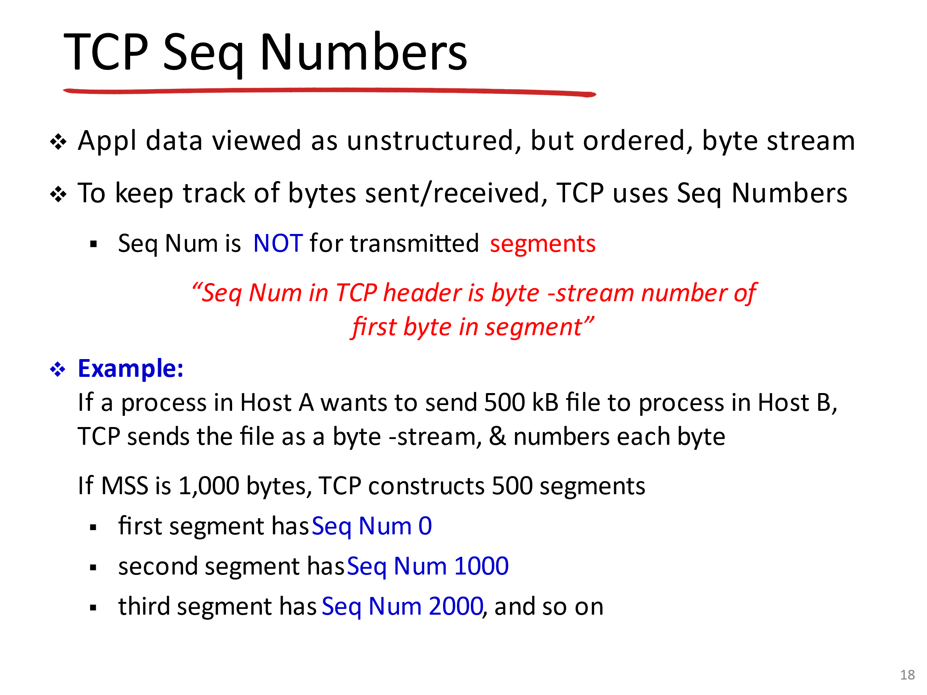TCP Sequence Numbers – Simple English Explanation

1. Byte Stream Concept
- TCP sees application data as a continuous stream of bytes (not separate messages).
- Each byte in the stream is numbered.

2. Sequence Numbers
- The sequence number in the TCP header is the number of the first byte in that segment.
- This helps the receiver know where each segment fits in the overall stream.
👉 Important: Sequence numbers are not for segments themselves, but for bytes inside the stream.

3. Example
- Suppose Host A wants to send a 500 KB file to Host B.
- TCP numbers each byte: 0, 1, 2, … up to 500,000.
- If MSS = 1000 bytes, TCP will create 500 segments.
  - Segment 1 → Seq Num = 0 (bytes 0–999)
  - Segment 2 → Seq Num = 1000 (bytes 1000–1999)
  - Segment 3 → Seq Num = 2000 (bytes 2000–2999)
  - … and so on.
This way, the receiver can reorder and reassemble the file correctly.

📗 Roman Urdu Explanation (Professor Style)
- Byte Stream Concept: TCP application data ko ek continuous byte stream ke taur pe dekhta hai. Matlab har byte ko ek number assign hota hai.
- Sequence Numbers: TCP header mein jo sequence number hota hai, wo segment ke pehle byte ka number hota hai. Ye receiver ko batata hai ke segment stream mein kahan fit hota hai.
👉 Note: Sequence number segment ke liye nahi, balki bytes ke liye hota hai.
- Example: Agar Host A ek 500 KB file bhejna chahta hai Host B ko, TCP har byte ko number karega: 0 se le kar 500,000 tak. Agar MSS = 1000 bytes hai, to TCP 500 segments banayega:
- Segment 1 → Seq Num = 0 (bytes 0–999)
- Segment 2 → Seq Num = 1000 (bytes 1000–1999)
- Segment 3 → Seq Num = 2000 (bytes 2000–2999)
- … aur aise hi aage.
Is tarah receiver file ko sahi order mein reassemble kar leta hai.

📝 Practice Questions

Multiple Choice (MCQs)
- In TCP, sequence numbers are assigned to: a) Segments b) Bytes in the stream c) Packets d) Frames
- The sequence number in a TCP header represents: a) Last byte in the segment b) First byte in the segment c) Segment number d) Window size
- If MSS = 1000 bytes, what will be the sequence number of the third segment? a) 2000 b) 3000 c) 1000 d) 0
- Why are sequence numbers important? a) For error detection b) For reordering and reliable delivery c) For flow control only d) For checksum calculation

True/False
- TCP sequence numbers are assigned to segments. → False (They’re for bytes)
- The sequence number in the header is the first byte of the segment. → True
- If MSS = 1000, the second segment starts at sequence number 2000. → False (It starts at 1000)
- Sequence numbers help in reordering data at the receiver. → True

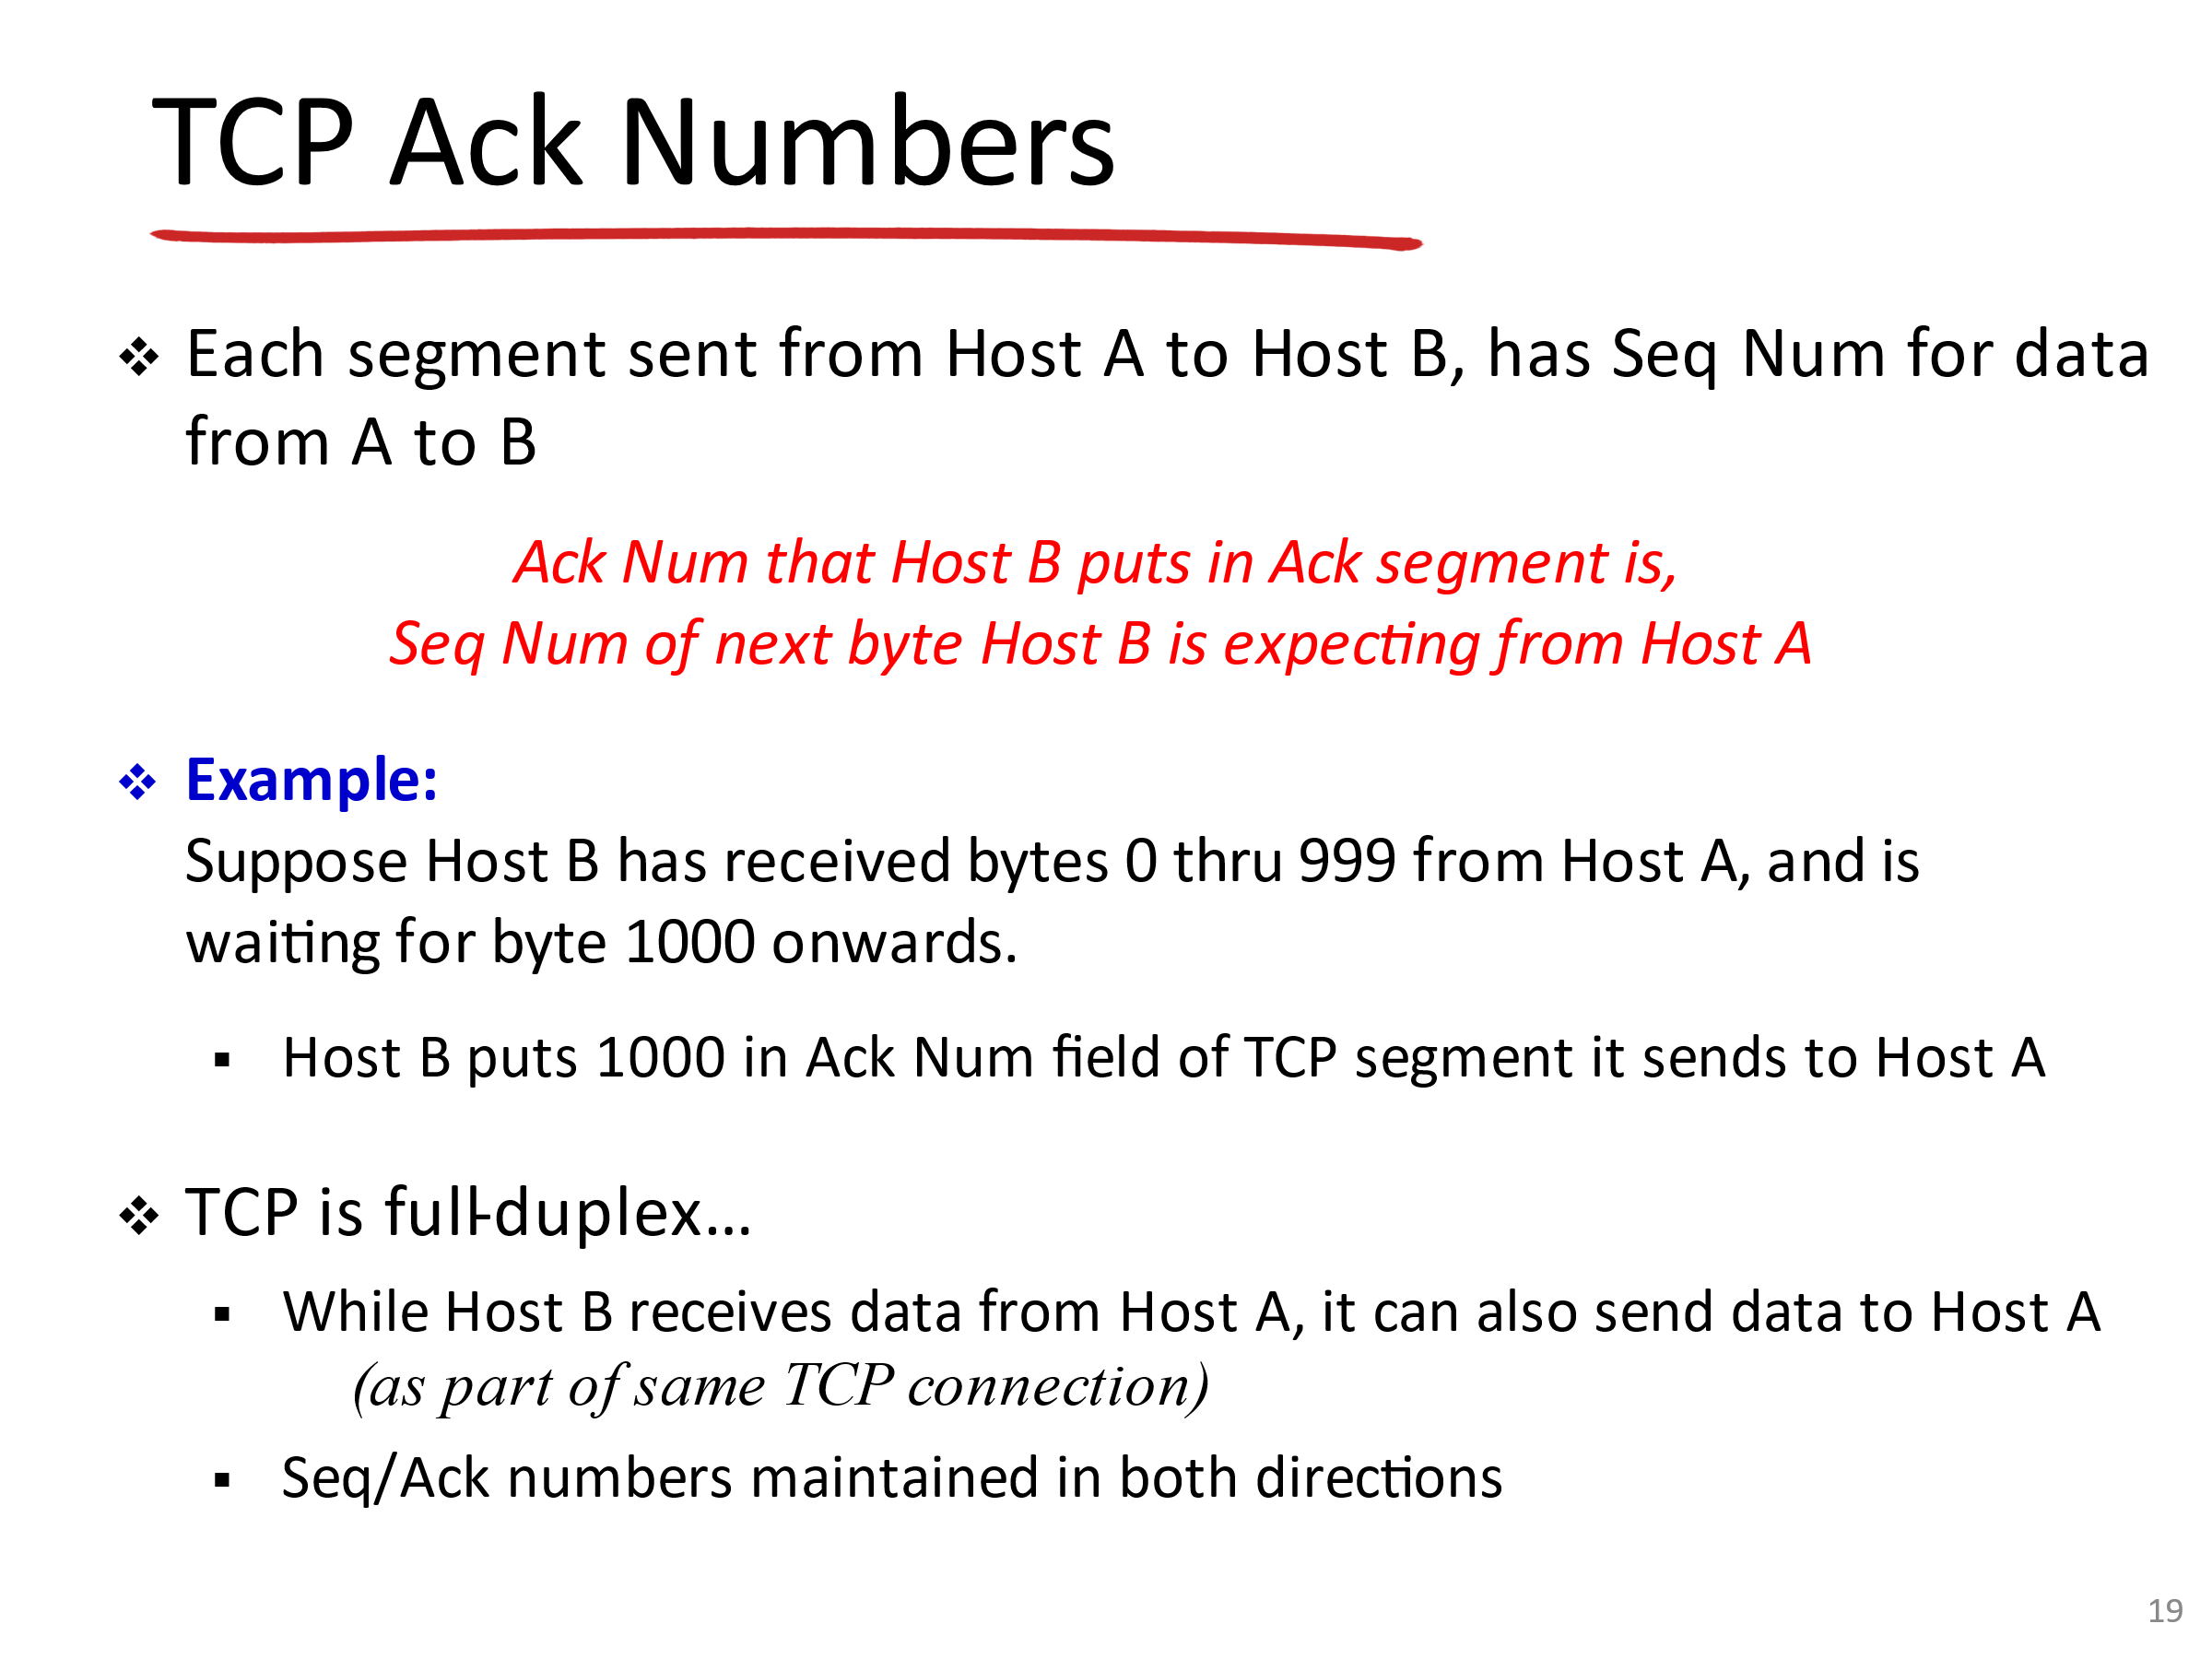📘 TCP Acknowledgment Numbers – Simple English Explanation

1. What is an Acknowledgment Number?
- Every TCP segment has a sequence number (for the bytes being sent).
- The acknowledgment number (Ack Num) tells the sender: 👉 “This is the next byte I’m expecting from you.”

2. How it Works
- Suppose Host B has received bytes 0 through 999 from Host A.
- That means the next byte Host B expects is 1000.
- So Host B sends back an ACK segment with Ack Num = 1000.
- This tells Host A: “I got everything up to 999, now send me byte 1000 onwards.”

3. Full Duplex
- TCP is full duplex.
- While Host B is acknowledging data from Host A, it can also send its own data to Host A.
- Both directions maintain their own sequence and acknowledgment numbers.
👉 Analogy: It’s like reading a book together. If you say “I’ve read up to page 10, now give me page 11,” that’s exactly what the acknowledgment number does.

📗 Roman Urdu Explanation (Professor Style)
- Acknowledgment Number kya hai? Har TCP segment mein ek sequence number hota hai jo bytes ko track karta hai. Acknowledgment number sender ko batata hai: 👉 “Main tumse agla byte expect kar raha hoon.”
- Kaise kaam karta hai? Maan lo Host B ne bytes 0 se 999 receive kar liye Host A se. Ab Host B ko agla byte 1000 chahiye. Is liye Host B ek ACK bhejta hai jisme Ack Num = 1000 hota hai. Ye Host A ko batata hai: “Mujhe 0 se 999 tak mil gaya, ab 1000 se aage bhejo.”
- Full Duplex: TCP full duplex hai. Matlab dono taraf ek hi waqt data bheja aur receive kiya ja sakta hai. Har direction apna sequence aur acknowledgment number maintain karta hai.
👉 Example: Ye bilkul kitab padhne jaisa hai. Agar aap kehte ho: “Main page 10 tak padh chuka hoon, ab page 11 do,” to yehi kaam acknowledgment number karta hai.

📝 Practice Questions

Multiple Choice (MCQs)
- The acknowledgment number in TCP represents: a) Last byte received b) Next byte expected c) Segment number d) Window size
- If Host B has received bytes 0–999, what Ack Num will it send? a) 999 b) 1000 c) 1001 d) 0
- TCP acknowledgment numbers are used for: a) Error detection b) Flow control c) Reliable delivery and ordering d) Multiplexing
- TCP is full duplex, meaning: a) Data flows one way only b) Data flows both ways simultaneously c) Only acknowledgments flow both ways d) None of the above

True/False
- The acknowledgment number is the last byte received. → False (It’s the next byte expected)
- TCP acknowledgment numbers ensure reliable delivery. → True
- TCP can only send data in one direction at a time. → False (It’s full duplex)
- If Host B sends Ack Num = 1000, it means it has received bytes 0–999. → True

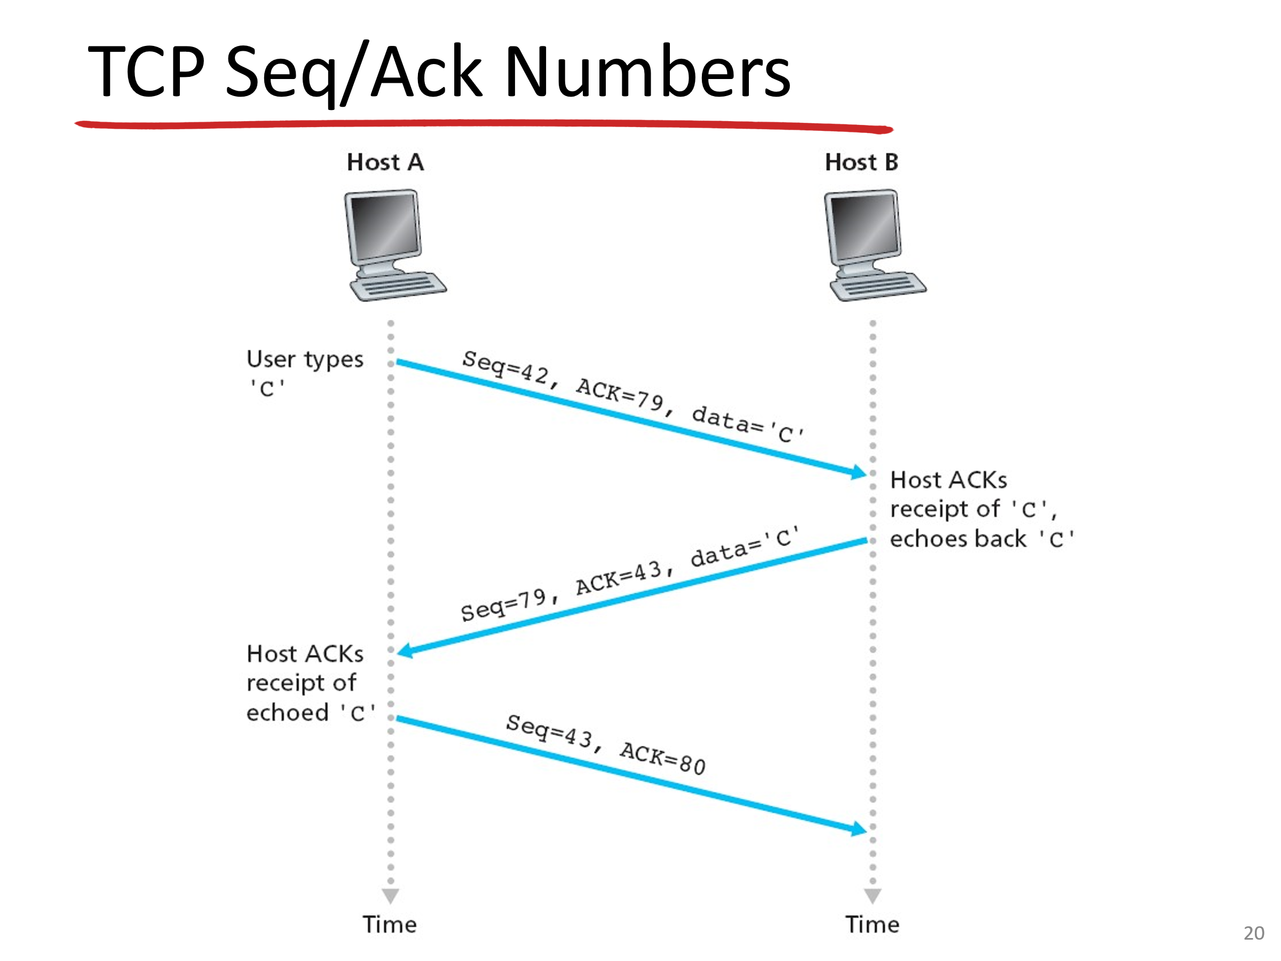TCP Seq/Ack Numbers – Simple English Explanation
This slide shows how sequence numbers and acknowledgment numbers work together during data transfer.

1. Sequence Numbers
- Each byte in TCP has a sequence number.
- The Seq Num in a segment is the number of the first byte being sent.

2. Acknowledgment Numbers
- The Ack Num tells the sender: “This is the next byte I expect from you.”
- It confirms receipt of all previous bytes.

3. Example (User types ‘C’)
- Host A sends data 'C' with Seq = 42, Ack = 79.
- Host B receives it, acknowledges with Ack = 43 (meaning it got byte 42 and now expects 43).
- Host B also sends back 'C' with Seq = 79 (its own sequence number).
- Host A then acknowledges with Ack = 80.
👉 This shows how both sides keep track of what has been sent and received. TCP is full duplex, so sequence and acknowledgment numbers are maintained in both directions.

📗 Roman Urdu Explanation (Professor Style)
- Sequence Numbers: TCP mein har byte ka ek sequence number hota hai. Segment ke andar jo pehla byte hota hai, uska number Seq Num field mein likha jata hai.
- Acknowledgment Numbers: Ack Num sender ko batata hai: “Main tumse agla byte expect kar raha hoon.” Matlab jitne bytes pehle mil gaye, unko confirm kar diya.
- Example (User types ‘C’):
- Host A data 'C' bhejta hai jisme Seq = 42, Ack = 79 hota hai.
- Host B receive karta hai aur Ack = 43 bhejta hai (matlab byte 42 mil gaya, ab 43 chahiye).
- Host B apna 'C' bhejta hai jisme Seq = 79 hota hai.
- Host A phir Ack = 80 bhejta hai.
👉 Ye process dikhata hai ke dono taraf sequence aur acknowledgment numbers maintain hote hain. TCP full duplex hai, matlab dono taraf ek hi waqt data bheja aur receive kiya ja sakta hai.

📝 Practice Questions

Multiple Choice (MCQs)
- The sequence number in TCP represents: a) Segment number b) First byte in the segment c) Last byte in the segment d) Window size
- The acknowledgment number in TCP represents: a) Last byte received b) Next byte expected c) Segment number d) Checksum
- If Host A sends Seq = 42, what Ack Num will Host B send back after receiving it? a) 42 b) 43 c) 44 d) 79
- TCP is full duplex, meaning: a) Data flows one way only b) Data flows both ways simultaneously c) Only acknowledgments flow both ways d) None of the above

True/False
- Sequence numbers are assigned to segments. → False (They’re for bytes)
- The acknowledgment number confirms the last byte received. → False (It’s the next byte expected)
- TCP maintains sequence and acknowledgment numbers in both directions. → True
- TCP is half duplex. → False (It’s full duplex)

🎯 Quick Recap
Concept | Explanation
Seq Num | First byte number in segment
Ack Num | Next byte expected
Example | Seq=42 → Ack=43
Full Duplex | Both sides send & receive simultaneously

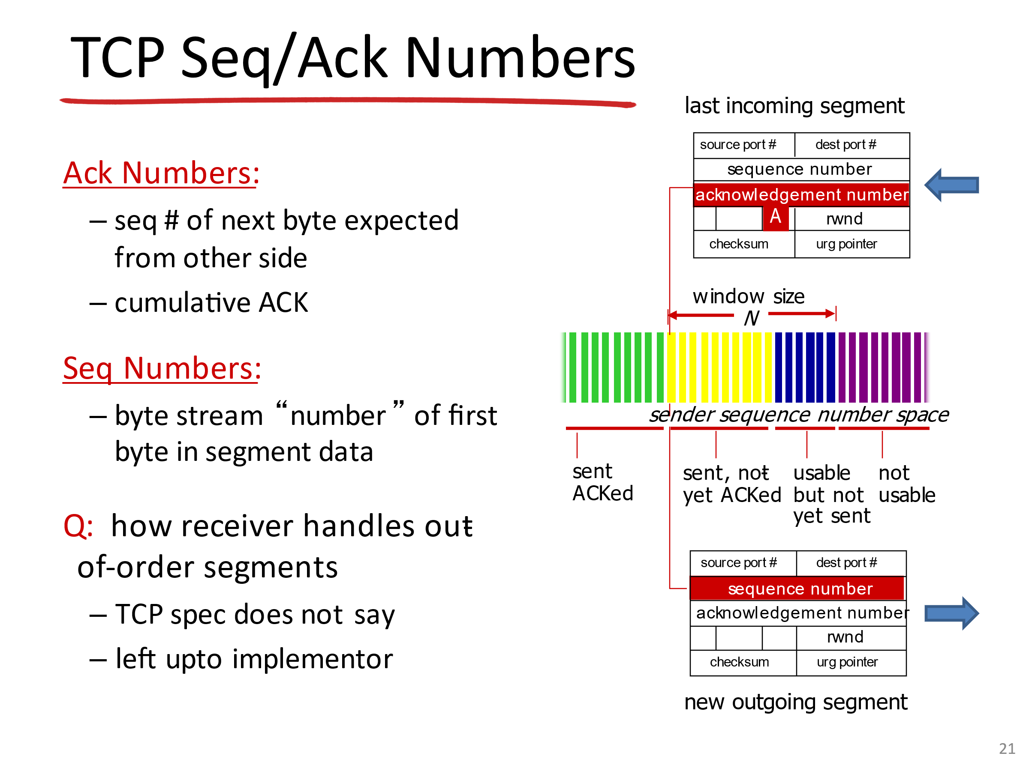📘 TCP Seq/Ack Numbers – Simple English Explanation

1. Sequence Numbers
- The Seq Num in TCP is the byte-stream number of the first byte in the segment.
- Example: If a segment carries bytes 2000–2999, its Seq Num = 2000.

2. Acknowledgment Numbers
- The Ack Num is the number of the next byte expected from the other side.
- It is cumulative ACK: meaning if Ack = 3000, the receiver has received everything up to 2999.

3. Sliding Window Concept
- TCP uses a window to control how much data can be sent before waiting for ACKs.
- The sender’s sequence number space is divided into:
  - Sent & ACKed → already confirmed.
  - Sent, not yet ACKed → waiting for acknowledgment.
  - Usable but not yet sent → can be sent now.
  - Not usable → outside the window, cannot send yet.
👉 This ensures flow control and reliability.

4. Out-of-Order Segments
- TCP specification does not strictly define how to handle out-of-order segments.
- It’s left to the implementor (different operating systems may handle it differently).

📗 Roman Urdu Explanation (Professor Style)
- Sequence Numbers: TCP mein Seq Num segment ke pehle byte ka number hota hai. Example: Agar segment bytes 2000–2999 carry karta hai, to Seq Num = 2000 hoga.
- Acknowledgment Numbers: Ack Num wo byte number hota hai jo receiver agla expect kar raha hai. Ye cumulative ACK hota hai. Matlab agar Ack = 3000 hai, to receiver ne 0 se 2999 tak receive kar liya hai.
- Sliding Window Concept: TCP ek window mechanism use karta hai jo control karta hai ke kitna data ek waqt mein bheja ja sakta hai. Sender ke sequence number space ke parts:
- Sent & ACKed → confirm ho chuka.
- Sent, not yet ACKed → abhi tak confirm nahi hua.
- Usable but not yet sent → abhi bheja ja sakta hai.
- Not usable → window ke bahar hai, abhi nahi bheja ja sakta.
👉 Ye mechanism flow control aur reliability ke liye zaroori hai.
- Out-of-Order Segments: TCP specification ye strictly define nahi karti ke out-of-order segments kaise handle karne hain. Ye implementor par depend karta hai (jaise Windows aur Linux alag tareeqe se handle kar sakte hain).

📝 Practice Questions

Multiple Choice (MCQs)
- The sequence number in TCP represents: a) Segment number b) First byte in the segment c) Last byte in the segment d) Window size
- The acknowledgment number in TCP represents: a) Last byte received b) Next byte expected c) Segment number d) Checksum
- If Ack = 3000, what does it mean? a) Receiver has received up to 2999 b) Receiver is waiting for byte 2999 c) Receiver has received only 3000 d) None
- The sliding window mechanism is used for: a) Error detection b) Flow control and reliability c) Multiplexing d) Message boundaries

True/False
- TCP acknowledgment numbers are cumulative. → True
- Seq Num is the last byte in the segment. → False (It’s the first byte)
- TCP sliding window divides sequence space into usable and unusable regions. → True
- TCP specification strictly defines out-of-order handling. → False

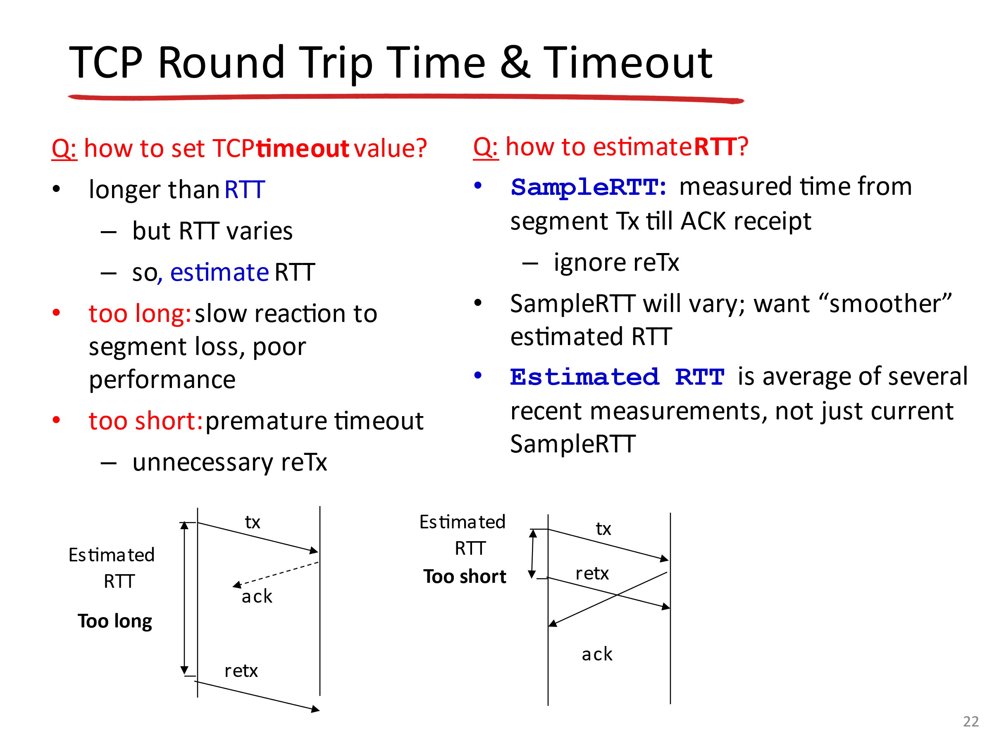TCP RTT & Timeout – Simple English Explanation

1. Why Timeout Matters
- TCP uses timeouts to detect lost segments.
- If an acknowledgment (ACK) doesn’t arrive within the timeout period, TCP retransmits the segment.
- Timeout must be set carefully:
  - Too long → slow reaction to losses, poor performance.
  - Too short → premature retransmissions, unnecessary overhead.

2. Round Trip Time (RTT)
- RTT = time from sending a segment until receiving its ACK.
- But RTT is not constant — it varies depending on network conditions.

3. Sample RTT
- Measured for each segment (excluding retransmissions).
- Example: If a segment is sent at time T1 and ACK arrives at T2, then SampleRTT = T2 – T1.

4. Estimated RTT
- Instead of using just the latest SampleRTT, TCP uses a smoothed average of several recent measurements.
- This avoids sudden jumps and gives a more stable estimate.
👉 Key Idea: Timeout ≈ Estimated RTT + some safety margin.

📗 Roman Urdu Explanation (Professor Style)
- Timeout kyun important hai? TCP timeout use karta hai taake lost segments detect ho saken. Agar ACK time par na aaye, TCP segment ko dobara bhejta hai. Timeout carefully set karna zaroori hai:
- Agar bohot lamba ho → loss detect karne mein der hogi, performance slow ho jayegi.
- Agar bohot chhota ho → premature retransmissions honge, unnecessary overhead hoga.
- Round Trip Time (RTT): RTT woh waqt hai jo ek segment bhejne aur uska ACK receive karne mein lagta hai. Ye constant nahi hota, network conditions ke hisaab se change hota hai.
- Sample RTT: Har segment ke liye measure kiya jata hai (retransmissions ko ignore karte hain). Example: Agar segment T1 pe bheja aur ACK T2 pe aya, to SampleRTT = T2 – T1.
- Estimated RTT: TCP ek smoothed average use karta hai jo recent SampleRTTs ka hota hai. Isse sudden changes avoid hote hain aur ek stable estimate milta hai.
👉 Important: Timeout ≈ Estimated RTT + safety margin.

📝 Practice Questions

Multiple Choice (MCQs)
- RTT stands for: a) Real Transmission Time b) Round Trip Time c) Reliable Transfer Time d) Random Transmission Time
- If timeout is set too short, what happens? a) Slow detection of loss b) Premature retransmissions c) Better performance d) None
- Sample RTT is measured from: a) Segment transmission to ACK receipt b) Connection setup to termination c) SYN to FIN d) Window size to checksum
- Estimated RTT is: a) Just the latest SampleRTT b) Average of several recent SampleRTTs c) Always fixed d) Equal to MSS

True/False
- Timeout must always be shorter than RTT. → False (It must be longer)
- RTT is constant in TCP. → False (It varies)
- Sample RTT ignores retransmissions. → True
- Estimated RTT is smoother than Sample RTT. → True

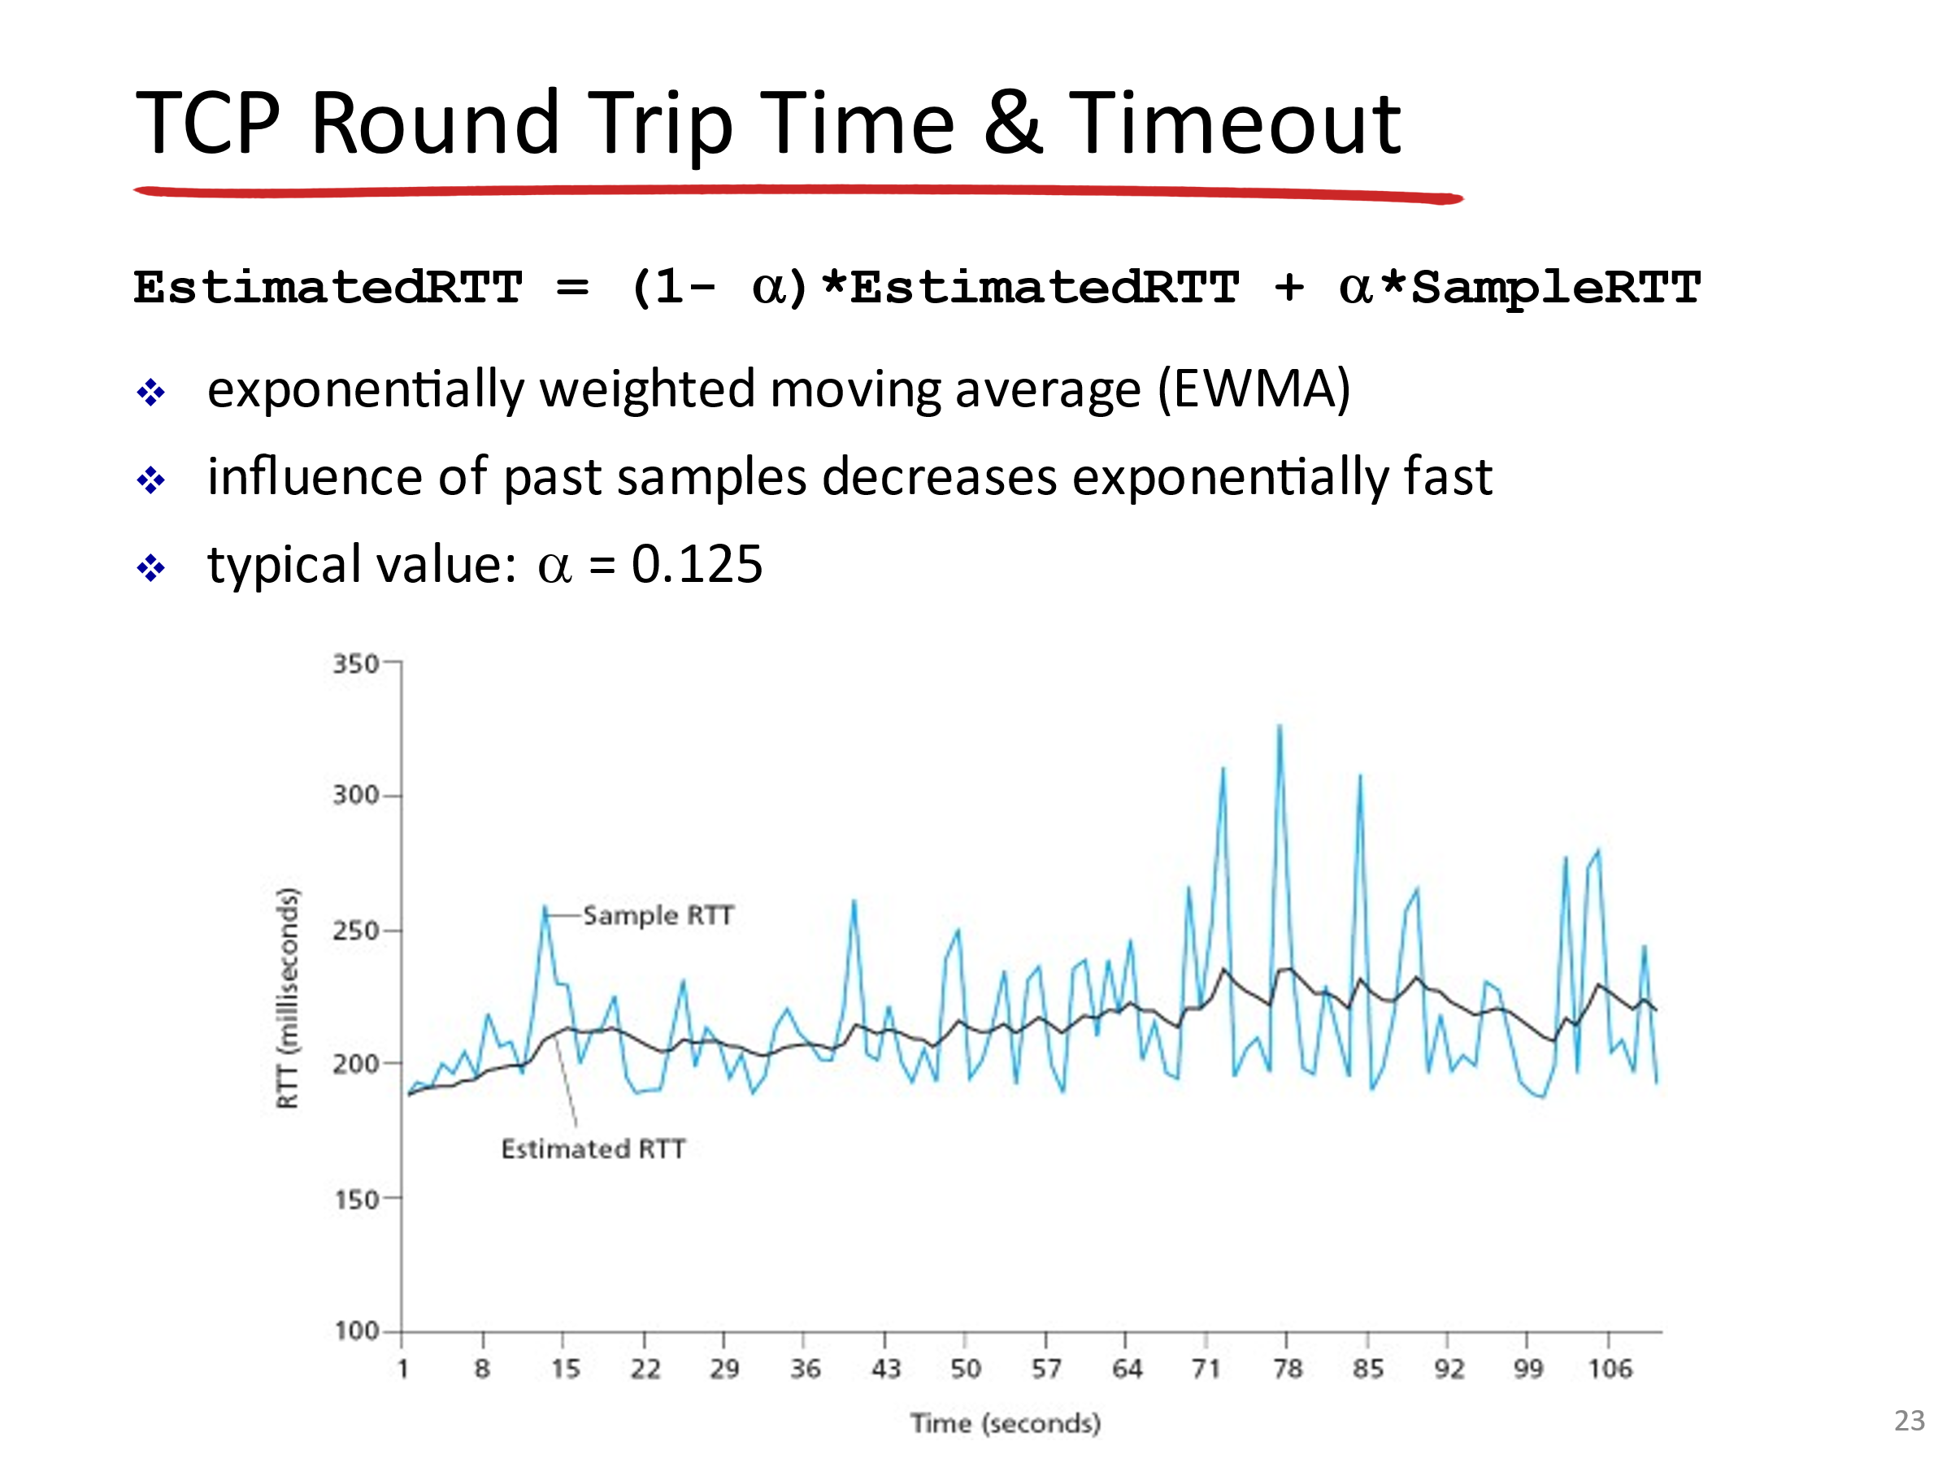TCP RTT Formula – Simple English Explanation

1. Formula
EstimatedRTT=(1−α)⋅EstimatedRTT+α⋅SampleRTT
- This is called an Exponentially Weighted Moving Average (EWMA).
- It smooths out fluctuations in SampleRTT.

2. How It Works
- SampleRTT = measured time from sending a segment until receiving its ACK.
- EstimatedRTT = smoothed average of past SampleRTTs.
- α (alpha) = weight factor (typical value = 0.125).
👉 Meaning:
- Recent samples influence the estimate, but older samples still matter.
- Influence of past samples decreases exponentially fast.

3. Why Important
- If we only used the latest SampleRTT, the timeout would jump around too much.
- Using EWMA gives a stable, reliable EstimatedRTT, which is then used to set the timeout value.

📗 Roman Urdu Explanation (Professor Style)
- Formula:
EstimatedRTT=(1−α)⋅EstimatedRTT+α⋅SampleRTT
Ye ek Exponentially Weighted Moving Average (EWMA) hai. Ye SampleRTT ke fluctuations ko smooth karta hai.
- Kaise kaam karta hai:
- SampleRTT = segment bhejne aur ACK receive karne ka measured time.
- EstimatedRTT = past SampleRTTs ka smoothed average.
- α (alpha) = weight factor (usually 0.125).
👉 Matlab: Recent samples zyada influence karte hain, lekin purane samples bhi thoda effect karte hain. Purane samples ka influence exponentially fast kam hota hai.
- Importance: Agar hum sirf latest SampleRTT use karein to timeout bohot jump karega. EWMA use karne se ek stable aur reliable EstimatedRTT milta hai, jo timeout set karne ke liye use hota hai.

📝 Practice Questions

Multiple Choice (MCQs)
- The formula for Estimated RTT uses: a) Linear average b) Exponentially Weighted Moving Average (EWMA) c) Median d) Maximum
- Typical value of α (alpha) is: a) 0.5 b) 0.25 c) 0.125 d) 1
- Why do we use EWMA instead of just SampleRTT? a) To make timeout jump faster b) To smooth fluctuations and get stable estimate c) To ignore old samples completely d) To reduce MSS
- If α is small, EstimatedRTT will: a) React quickly to new samples b) React slowly, giving more weight to past samples c) Ignore past samples d) None

True/False
- Estimated RTT is based only on the latest SampleRTT. → False
- EWMA gives more weight to recent samples. → True
- Typical α value is 0.125. → True
- Influence of past samples decreases linearly. → False (It decreases exponentially)

🎯 Quick Recap
Concept | Explanation
SampleRTT | Measured time from send → ACK
EstimatedRTT | Smoothed average using EWMA
α (alpha) | Weight factor (usually 0.125)
Purpose | Stable timeout calculation
Effect | Recent samples matter more, old samples fade

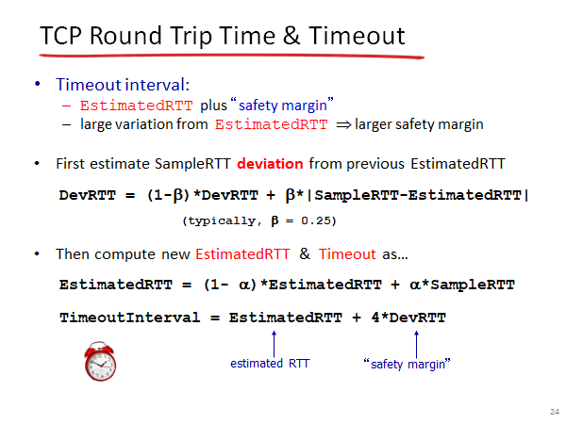TCP Timeout Interval – Simple English Explanation

1. Timeout Interval
- TCP sets the TimeoutInterval to detect lost segments.
- Formula:
TimeoutInterval=EstimatedRTT+4⋅DevRTT
- This means:
  - Start with the EstimatedRTT (smoothed average).
  - Add a safety margin (based on deviation).

2. Deviation (DevRTT)
- Measures how much the SampleRTT varies from the EstimatedRTT.
- Formula:
DevRTT=(1−β)⋅DevRTT+β⋅∣SampleRTT−EstimatedRTT∣
- Typical value: β = 0.25.
- If RTT fluctuates a lot, DevRTT becomes larger → bigger safety margin.

3. Estimated RTT
- Still calculated using EWMA:
EstimatedRTT=(1−α)⋅EstimatedRTT+α⋅SampleRTT
- Typical value: α = 0.125.

4. Key Idea
- Timeout must adapt to network conditions.
- If RTT is stable → small DevRTT → shorter timeout.
- If RTT varies → large DevRTT → longer timeout.

📗 Roman Urdu Explanation (Professor Style)
- Timeout Interval: TCP timeout set karta hai taake lost segments detect ho saken. Formula:
TimeoutInterval=EstimatedRTT+4⋅DevRTT
Matlab: EstimatedRTT ke sath ek safety margin add karte hain jo DevRTT par depend karta hai.
- Deviation (DevRTT): Ye measure karta hai ke SampleRTT aur EstimatedRTT mein kitna farq hai. Formula:
DevRTT=(1−β)⋅DevRTT+β⋅∣SampleRTT−EstimatedRTT∣
Typical β = 0.25. Agar RTT bohot fluctuate kare to DevRTT bada ho jata hai → safety margin bhi bada ho jata hai.
- Estimated RTT: Ye EWMA se calculate hota hai:
EstimatedRTT=(1−α)⋅EstimatedRTT+α⋅SampleRTT
Typical α = 0.125.
- Key Idea: Timeout network ke conditions ke hisaab se adjust hota hai.
- Agar RTT stable hai → DevRTT chhota → timeout short.
- Agar RTT vary karta hai → DevRTT bada → timeout long.

📝 Practice Questions

Multiple Choice (MCQs)
- Timeout interval in TCP is calculated as: a) EstimatedRTT only b) EstimatedRTT + DevRTT c) EstimatedRTT + 4 × DevRTT d) SampleRTT + DevRTT
- DevRTT measures: a) Average RTT b) Variation between SampleRTT and EstimatedRTT c) Window size d) Sequence numbers
- Typical value of β is: a) 0.125 b) 0.25 c) 0.5 d) 1
- If RTT fluctuates a lot, what happens to TimeoutInterval? a) It decreases b) It increases c) It stays fixed d) None

True/False
- TimeoutInterval = EstimatedRTT + 4 × DevRTT. → True
- DevRTT measures average RTT. → False (It measures variation)
- Typical β value is 0.25. → True
- If RTT is stable, TimeoutInterval becomes shorter. → True

🎯 Quick Recap
Concept | Formula | Purpose
EstimatedRTT | EWMA of SampleRTT | Smoothed average
DevRTT | EWMA of deviation | Measures variation
TimeoutInterval | EstimatedRTT + 4 × DevRTT | Adaptive timeout
α | 0.125 | Weight for SampleRTT
β | 0.25 | Weight for deviation

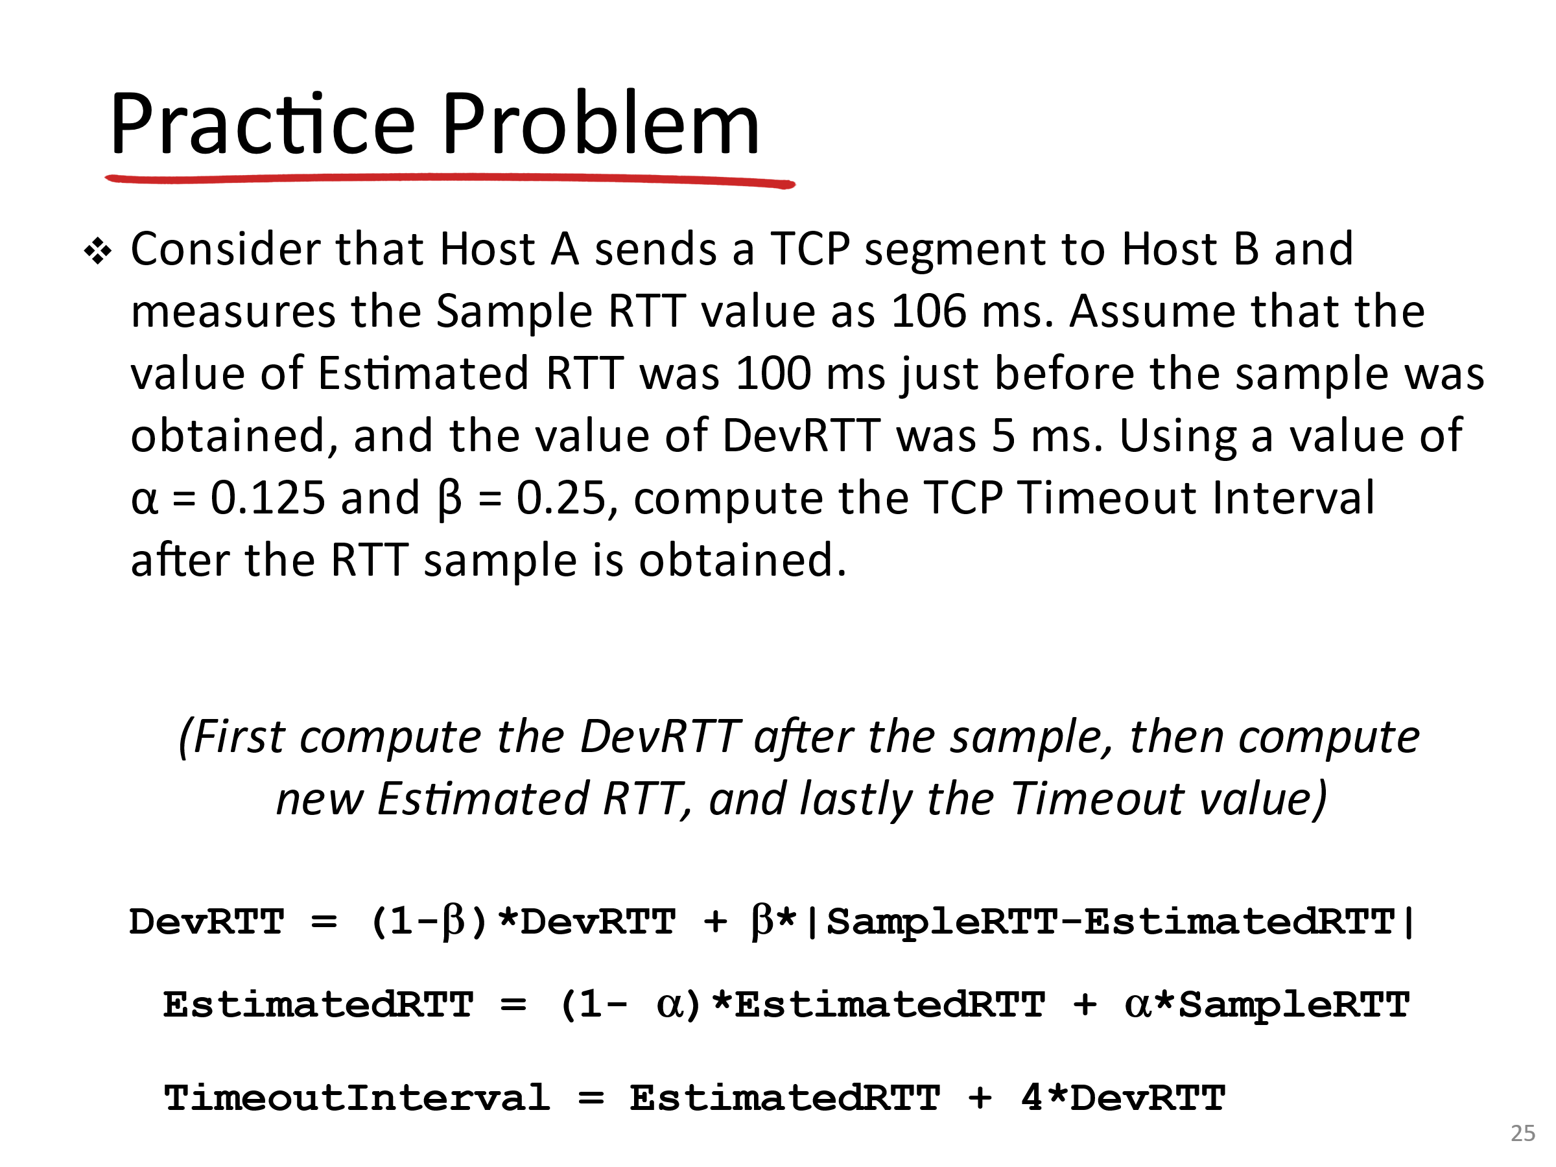Problem Statement (English)
We are given:
- SampleRTT = 106 ms
- EstimatedRTT (previous) = 100 ms
- DevRTT (previous) = 5 ms
- α = 0.125
- β = 0.25
We need to compute:
- New DevRTT
- New EstimatedRTT
- New TimeoutInterval

Step 1: Compute DevRTT
Formula:
DevRTT=(1−β)⋅DevRTT+β⋅∣SampleRTT−EstimatedRTT∣
Plugging values:
DevRTT=(1−0.25)⋅5+0.25⋅∣106−100∣
=0.75⋅5+0.25⋅6
=3.75+1.5=5.25 ms

Step 2: Compute EstimatedRTT
Formula:
EstimatedRTT=(1−α)⋅EstimatedRTT+α⋅SampleRTT
Plugging values:
EstimatedRTT=(1−0.125)⋅100+0.125⋅106
=0.875⋅100+0.125⋅106
=87.5+13.25=100.75 ms

Step 3: Compute TimeoutInterval
Formula:
TimeoutInterval=EstimatedRTT+4⋅DevRTT
Plugging values:
TimeoutInterval=100.75+4⋅5.25
=100.75+21=121.75 ms
✅ Final Answer:
- DevRTT = 5.25 ms
- EstimatedRTT = 100.75 ms
- TimeoutInterval = 121.75 ms

📗 Roman Urdu Explanation (Professor Style)
- DevRTT Calculation: Formula:
DevRTT=(1−β)⋅DevRTT+β⋅∣SampleRTT−EstimatedRTT∣
Values dalte hain:
=(0.75⋅5)+(0.25⋅6)=3.75+1.5=5.25 ms
- EstimatedRTT Calculation: Formula:
EstimatedRTT=(1−α)⋅EstimatedRTT+α⋅SampleRTT
Values dalte hain:
=(0.875⋅100)+(0.125⋅106)=87.5+13.25=100.75 ms
- TimeoutInterval Calculation: Formula:
TimeoutInterval=EstimatedRTT+4⋅DevRTT
Values dalte hain:
=100.75+(4⋅5.25)=100.75+21=121.75 ms
👉 Matlab: TCP ka timeout ab 121.75 ms set hoga.

📝 Practice Questions

Multiple Choice (MCQs)
- If SampleRTT = 106 ms and EstimatedRTT = 100 ms, what is |SampleRTT – EstimatedRTT|? a) 5 b) 6 c) 7 d) 8
- With β = 0.25, DevRTT update formula is: a) DevRTT = 0.75 × old DevRTT + 0.25 × difference b) DevRTT = 0.5 × old DevRTT + 0.5 × difference c) DevRTT = old DevRTT only d) None
- TimeoutInterval is calculated as: a) EstimatedRTT + DevRTT b) EstimatedRTT + 4 × DevRTT c) SampleRTT + DevRTT d) EstimatedRTT only

True/False
- TimeoutInterval depends on both EstimatedRTT and DevRTT. → True
- DevRTT measures variation in RTT. → True
- EstimatedRTT is always equal to SampleRTT. → False
- TimeoutInterval in this problem is 121.75 ms. → True

